
National University of Sciences & Technology (NUST) Balochistan Campus (NBC),
Department of Computer Science
Department of Computing
CS-250: Data Structure and Algorithms
Class: BSCS Fall 2022
Lab 5: Implmentation of Stacks in different problems
Date: 16th October, 2023
Time: 10 am - 1 pm

NAME | SAMEER TALREJA
CMS | 457795
SEMESTER | 3RD

CS250: Data Structures and Algorithms Page 1

National University of Sciences & Technology (NUST) Balochistan Campus (NBC),
Department of Computer Science
Lab 5: Implmentation of Stacks in different problems
Introduction
This lab consists of stacks implementation and some of its applications.
Objectives
Objective of this lab is to enable students to build stack ADT using linked list and arrays, perform the following tasks on it and analyze the performance of each implementation.
Tools/Software Requirement
Visual Studio c++
Helping Material
Lecture slides, text book
Description
A stack meant to mimic the information storage and retrieval in LIFO (Last In First Out) order. 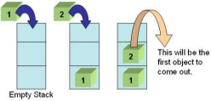
Stack Operations
1. void Push(element) – pushes an element on the top of stack
2. element Pop() – removes and display the element on the top of stack
CS250: Data Structures and Algorithms Page 2

National University of Sciences & Technology (NUST) Balochistan Campus (NBC),
Department of Computer Science
3. boolisEmpty() – checks if the stack is empty or not
4. boolisFull() – checks if the stack is full or not
5. void Clear() – release the memory allocated by stack
6. void Peak() – display the contents of the top element of stack
Lab Tasks
Task 1:
The idea is rather simple: You keep a Stack of braces, and every time you encounter an open brace, you push it into your stack. Every time you encounter a close brace, you pop the top element from your stack. At the end, you check your stack for being empty. If so, indeed your input string contained balanced braces. Otherwise, it didn't.
Expected Input
1. 1 + 2 * (3 / 4)
2. 1 + 2 * [3 * 3 + {4 – 5 (6 (7/8/9) + 10) – 11 + (12*8)] + 14
3. 1 + 2 * [3 * 3 + {4 – 5 (6 (7/8/9) + 10)} – 11 + (12*8) / {13 +13}] + 14
Your program will determine whether the open brackets (the square brackets, curly braces and the parentheses) are closed in the correct order.
Expected Output
1. This expression is correct.
2. This expression is NOT correct e.g. error at character # 10. ‘{‘- not closed. 3. This expression is correct.
Your program should be able to take generic input expression from user
Solve the above problem using an array based stack.
Important Note: Practice your knowledge of OOP with C++ when creating a solution.
Solution:
Solution
Task 1 Code:
#include <iostream>
#include <string>
using namespace std;

class Stack {
char* arr;
int top;
int size;

public:
Stack(int size) {
this->size = size;
top = -1;
arr = new char[size];
}

void push(char data) {
if (top < size - 1) {
top++;
arr[top] = data;
} else {
cout << "Stack overflow" << endl;
}
}

void pop() {
if (top > -1) {
top--;
} else {
cout << "Stack is empty" << endl;
}
}

char peek() {
if (top > -1) {
return arr[top];
} else {
cout << "Stack underflow" << endl;
return '\0'; // Return null character if underflow
}
}

bool isEmpty() {
return top == -1;
}

~Stack() {
delete[] arr;
}
};

bool matches(char open, char close) {
return (open == '(' && close == ')') ||
(open == '{' && close == '}') ||
(open == '[' && close == ']');
}

bool checkBalancedBraces(const string& expression) {
Stack s(expression.length());
for (int i = 0; i < expression.length(); i++) {
char c = expression[i];
if (c == '(' || c == '{' || c == '[') {
s.push(c);
} else if (c == ')' || c == '}' || c == ']') {
if (s.isEmpty() || !matches(s.peek(), c)) {
cout << "This expression is NOT correct. Error at character #" << i+1 << ": '" << c << "' - not matched.\n";
return false;
}
s.pop();
}
}
if (s.isEmpty()) {
cout << "This expression is correct.\n";
return true;
} else {
cout << "This expression is NOT correct. Some braces are not closed.\n";
return false;
}
}

int main() {
string expression;
cout << "Enter an expression to check: ";
getline(cin, expression);
checkBalancedBraces(expression);
return 0;
}

Task 1 Output Screenshot:
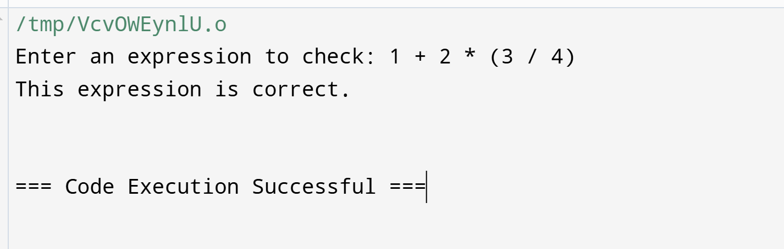
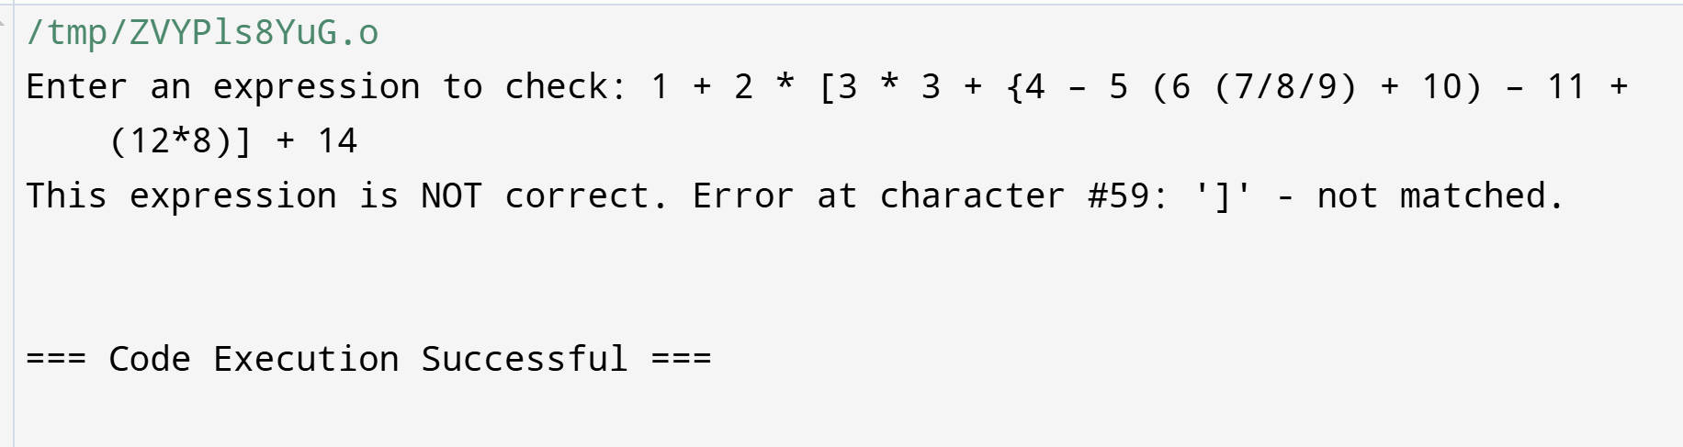
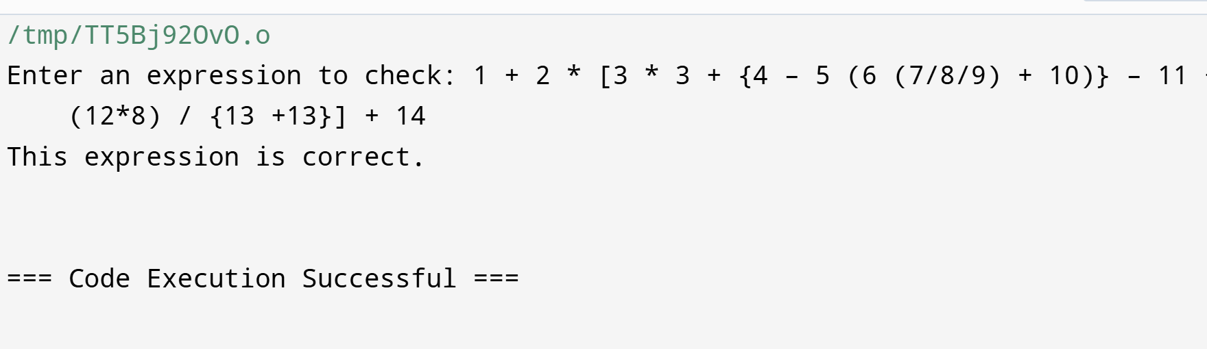

CS250: Data Structures and Algorithms Page 3

National University of Sciences & Technology (NUST) Balochistan Campus (NBC),
Department of Computer Science
Deliverables
Compile a single word document by filling in the solution part and submit this Word file on LMS. This lab grading policy is as follows: The lab is graded between 0 to 10 marks. The submitted solution can get a maximum of 5 marks. At the end of each lab or in the next lab, there will be a viva related to the tasks. The viva has a weightage of 5 marks. Insert the solution/answer in this document. You must show the implementation of the tasks in the designing tool, along with your complete Word document to get your work graded. You must also submit this Word document on the LMS. In case of any problems with submissions on LMS, submit your Lab assignments by emailing it to Mr. Safder Ali students.em96@gmail.com .
CS250: Data Structures and Algorithms Page 4

